TIMS3311

Innovation and Entrepreneurship in Practice

Reflective Diary & Critical Reflection

Student Name: Paige Pomeroy
Student Number: 48024709

Reflection Word Count: 1587
Diary Entry Word Count: 1240

Semester 2, 2025

Critical Reflection Essay | Overall WIL Experience
Personal Lessons
Through my WIL experience with Eclipse, I learned a great deal about myself and my capacity to adapt in a real-world entrepreneurial setting. In particular, I discovered that I thrive when faced with ambiguity. Being a part of a live venture required navigating situations where there wasn’t always a clear direction or ‘right answer’, from designing MVP concepts to interpreting customer insights. I learned I’m more resourceful than I thought, finding creative ways to test ideas with constraints of available resources, time and skills. I found it fascinating how an interview could start in one direction and completely shift based on the participant’s perspective, revealing unexpected needs, behaviours, or motivations. However, a personal challenge for me was balancing the desire to perfect ideas with the need to move quickly. Early on, I noticed I could get caught up refining visuals or concepts rather than testing them, which slowed progress. Overcoming this meant embracing the ‘fail fast, learn quickly’ mindset.
Network Establishment
During my WIL experience, I was lucky to develop valuable networks both within our student team and the start-up ecosystem. Working closely with Siobhan Coster, the CEO, I gained first-hand insight into what it’s like to manage a start-up venture, specifically within the bio-tech industry. Siobhan not only guided our team through approaching interviews and MVP development, but also supported us in the TIMS3310 course, where we interviewed her as part of a leadership assignment using a wellbeing polarity approach. What I found most interesting from Siobhan’s experience is the challenges she faces with legal and regulatory aspects of running a venture. As she has three phase’s she wants the venture to step into, being lactoferrin in skincare, food and eventually baby formula, each comes with its own unique set of barriers, which has given me a real appreciation for the complexity of scaling a start-up across multiple industries.
New Knowledge, Insights and Skills
The Past
Prior to commencing this course, I had limited practical experience in entrepreneurship and innovation, having mainly engaged only with theoretical concepts throughout my time at university. What particularly sticks out to me is my time in the TIMS3302 course with Russel, where I was part of a team who created the venture idea ‘Bite Back’, which aimed to address food waste on campus by connecting students with local vendors offering discounted surplus meals. Our team used a lean, low-cost approach to develop a Facebook based MVP to test the assumptions that students actively seek affordable, convenient food options, and that vendors are willing to participate. This involved surveying students, collaboration with vendors, and refining the model based on feedback. Similarly, in TIMS1301, I worked on Geo Watch, a smart soil management system for mine site rehabilitation. Over six weeks, our team conducted extensive customer discovery interviews, leveraged personal industry connections, and developed a functional prototype app. These experiences allowed me to apply frameworks such as lean start-up principles and MVP testing in future endeavours.
Concepts and Theories
Throughout the WIL experience working with the start-up venture Eclipse Ingredients, the most significant entrepreneurial frameworks I engaged with were lean start-up (60%), design thinking (30%), and effectuation (10%), each shaping how myself and my team approached uncertainty and innovation. The first building block of our entrepreneurial approach was effectuation, as this provided us with the means of thinking about where to start and what resources we have currently available to leverage at the beginning of our journey. For Eclipse, this meant identifying what was already accessible, which we discovered was Siobhan’s professional networks, our own individual personal networks and expertise, and a few connections within the local skincare industry. This links with Sarasvathy (2022), whereby ‘effectual reasoning encourages entrepreneurs to begin with the means at hand, leveraging their existing skills, networks, and resources, rather than waiting for ideal conditions. This mindset anchored our approach in actionable decision-making, allowing us to focus on what we could achieve immediately with the resources at hand.
Reflecting on my WIL experience, it is clear the lean start-up framework was the most beneficial in guiding our team along our entrepreneurial journey. Our emphasis on the theoretical approach “build-measure-learn” experimentation from Blank (2013), allowed us to rapidly test assumptions and iteratively refine our ideas based on customer feedback, working on validating lactoferrin’s potential applications in skincare. It became apparent we had been over-prioritising internal analysis rather than real-world validation, following feedback from Jack after our A1 presentation in week 5. In response, we pivoted our approach, shifting from hypothetical strategy development to rapid customer discovery. This is where our team thoroughly adopted the lean start-up mindset, designing three visual MVP concepts representing different value propositions, anti-aging, anti-acne, and hydration. This was then categorised into moisturiser, sunscreen or serums, after Siobhan mentioned Lactoferrin provided more benefits within leave-on products, rather than wash-off products. These MVP product concepts were displayed in our survey, which were distributed to 53 participants across Brisbane, including university students and beauty retail professionals, gathering feedback that directly informed our next MVP iterations. This process allowed us to identify which concepts resonated with different segments and refine our approach based on real-world insights. Personally, the lean start-up process helped me remain grounded, and remind me that successful ventures are not built on hard plans, but these trial and error processes, ultimately becoming the most transformative approach for how I understood entrepreneurship within a real life application.
Complimenting the lean start-up framework, the design thinking framework was utilised to ground our work in empathy towards customers pain points, needs and desires. We followed a cyclical process of ‘empathising, defining, ideating, prototyping, and testing’ each encouraging a deep understanding of the problem space (Jaskyte, 2022). After discussion with Siobhan at the beginning of the WIL project, we created a timeline of the processes to pursue. We began this process by empathising, through conducting interviews and mapping customer journeys to understand the experiences, needs, and frustrations of different skincare users. Our team completed one-on-one interviews with a total of 30 participants, 14 women, 13 men, and 3 beauty retail professionals. Prior to conducting these interviews, our assumptions were that women would prioritise anti-aging benefits, men would be largely uninterested in skincare, and beauty retail professionals would be intrigued by the benefits surrounding lactoferrin. However, after mapping insights using empathy mapping to inspect each segment’s thoughts, feelings, behaviours, pains, and gains, it was clear we discovered underlying needs that were not initially apparent. These were found to be that women prioritised gentle, effective products with hydration and simplicity, relying on reviews and social proof. Men valued convenience and simple, evidence-based routines. Beauty retail professionals focused on clear messaging, client feedback, and scientifically backed ingredients like lactoferrin. This process allowed us to challenge our assumptions and highlight our internal biases, ultimately reinforcing the importance of early validation. Conducting interviews and synthesising the findings deepened my understanding of how critical empathy and iterative feedback are in designing solutions that genuinely resonate with target audiences. Personally, this experience has shown me that in future entrepreneurial or professional roles, I will prioritise early customer engagement and evidence-based decision-making, ensuring that strategies and innovations are grounded in real-world insights rather than assumptions.

The Future
The key takeaway from this WIL practical experience is the importance of understanding target audiences, testing and managing concepts, and using real world data to guide decision making, all skills which are directly applicable to a future career trajectory in marketing. For example, conducting both consumer and professional interviews for Eclipse taught me how to identify key motivators, preferences, and pain points, which in respective to marketing, can inform product positioning, campaign strategy and market segmentation. Iterative testing and the challenging of assumptions throughout the WIL experience, specifically in regards to the MVP’s and survey questions, showed me the importance of grounding ideas in evidence-based insights, which can correlate to driving engagement and building brand trust from a marketing aspect.
Course Recommendations
The most valued aspect of this course for me is the ability to apply theoretical knowledge and frameworks, in real practical venture settings. Where previously mentioned frameworks move beyond abstract ideas and are tested in practice. As of now, this course has been the first opportunity for me to do so, and has expanded my perspective on how theory informs practice. However, the following suggestions have been made to improve this course to compliment the placements:
- It is clear this course is self-guided, which encouraged me to take ownership of my learning and manage my time effectively. However, I think the course could be improved by providing more examples of how previous students approached their placements, which would help set expectations and inspire strategies for tackling challenges. This could be done through Zoom sessions with previous students who benefited from the course or by sharing their personal statements, similar to Siobhan’s experience.
- Building on this, I suggest implementing more structured reflection checkpoints throughout the placement. Scheduled opportunities to review progress and challenges would help consolidate learning and bridge the gap between theory and practice. While foundational knowledge of the frameworks was assumed at the start of the course, applying them effectively in a real-world context with Eclipse proved more challenging than I anticipated.
- I also suggest pairing teams so that two teams are mutually accountable for each other’s progress, which fosters regular check-ins to review milestones and provide feedback to each other. This would also prove interesting if two placement groups were working with entirely different ventures, allowing students to gain insight into how two distinct businesses approach challenges, make decisions, and apply entrepreneurial frameworks, ultimately enhancing learning through comparison and reflection.

References
Blank, S. (2013). Why the lean start-up changes everything. Harvard Business Review, 91(5), 64–72.
Jaskyte, K., & Liedtka, J. (2022). Design thinking for innovation: Practices and intermediate outcomes. Nonprofit Management & Leadership, 32(4), 555–575)
Sarasvathy, S. D. (2022). Effectuation : elements of entrepreneurial expertise. Edward Elgar.

Diary Entries
Diary Entry #1 | 13th August
Prior to commencing the course, my understanding of entrepreneurship is that it is the process of identifying opportunities, creating value, and turning ideas into viable ventures. I have had a bit of exposure to theory of design thinking, effectuation, and lean start-up, however I have yet to apply this knowledge in a practical setting. As I start this course, I’m hoping to deepen my understanding of the entrepreneurial mindset, not just how to start a business, but how to think creatively, test assumptions, and adapt ideas through real-world learning.
After being pitched several start-up ventures, I was immediately drawn to Eclipse because it offered clear structure and room for innovation. The venture has strong foundations, prior development, and clear goals, with an evident sense of passion from the CEO Siobhan Coster. From there I met like-minded individuals where we formed a team. Eloise was chosen as team captain due to her strong sense of goal setting and organisation skills, while we divided the other roles based on our individual strengths. I took responsibility for researching Eclipse’s positioning, competitor landscape, and consumer trends in the APAC region. Other team members focused on methodology design, problem interviews, and timelines. Ultimately, our collective goal was to validate lactoferrin’s value proposition, and whether its strongest market fit would be reflected in the anti-acne, anti-aging, or anti-inflammatory sector.
At this stage, our approaches reflect Effectuation theory, where we begin identifying our ‘means’ of skills, connections, and tools already at our disposal. Reflecting back, this mindset helped us work with uncertainty, using what we had rather than waiting for perfect information.
Table of Allocated Roles
 | Roles Set #1 (PowerPoint Design and Speech) | Role Set #2 | Role Set #3
Bella | Expected deliverables and outcomes | Interviews x 7, BMC | -Mock up of products Design
Eloise | Executive Summary, Problem Deep Dive | -Means inventory BMC  -Write interview questions  -Interview x 3  -Empathy mapping results from interviews  -Create survey questions  -Create survey | -Mock up of products Design  -Print Flyers and Disperse
Paige | WIL Context and Landscape | Interviews x 6, BMC | -Flyer Design  -Print Flyers and Disperse
Crystal-Rose | Methodology and Approach | Interviews x 7, BMC | -Print Flyers and Disperse
Ruby | Resources and implementation | Interviews x 7, BMC | -Print Flyers and Disperse

Table of Team Allocation and Presenting Date
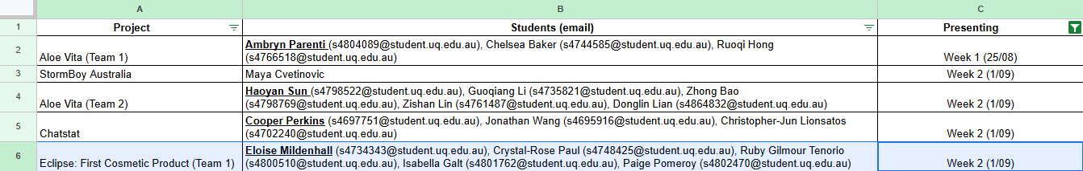
Table of Excepted Output Deliverables
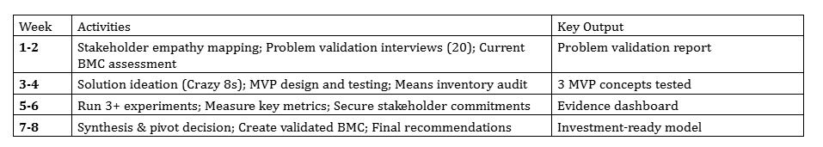
Diary Entry #2 | 1st September
Our team delivered our A1 presentation for Eclipse Ingredients, marking an important checkpoint for both myself and the team in understanding how to apply entrepreneurial tools in real world venture context. Preparing for this milestone helped us move beyond surface level research, and start critically analysing and delving into Eclipse’s market validation process for lactoferrin in skincare (Phase 1). As mentioned in Diary Entry #1, our biggest assumption was assuming our biggest challenge would come from identifying which value proposition (market segment), would resonate most with B2B partners. However, after our first meeting with Siobhan (after establishing a recurring 30-minute meeting once a week to ensure consistent feedback) it became clear that before testing value propositions, we needed to fully understand Eclipse’s resources, networks and strengths, prompting us to form a means Inventory. We found Eclipse currently has gaps in market data, with no clear product-market fit within the skincare industry.
Our immediate learning was how useful the Business Model Canvas (BMC) can be as a shared visual framework. Building it together helped us see how each component like value proposition, partners, and revenue streams, connects to Eclipse’s long-term goal of entering the APAC skincare market. Upon reflection, this deepened my understanding of how assumptions, structure, and collaboration interact in entrepreneurial projects.
Table of Meeting times and Notes
Date | Time | Notes
Monday 1st September | 10:30am-11:00am | Research regulations and barriers surrounding acne skincare, as products cannot be directly advertised for acne treatment initially.  Explore how to leverage all benefits of lactoferrin for a skincare product, not just its acne-related properties.  Note that while acne benefits are valuable, it’s harder to market legally as an acne treatment due to regulatory restrictions.  Communicate the full range of lactoferrin’s benefits to Eclipse, so they can pass this information to businesses selling the product.  Address potential consumer bias around animal-derived ingredients and clarify that lactoferrin is fully vegan despite misconceptions.  Cost is not a major concern, as highly active ingredients require only small inclusion rates.  Prepare interview questions that are:  -Simple and accessible, keeping the target market broad.  -Inclusive of men to test male interest in the product.  -Aimed at identifying potential age markets and demographic preferences
Monday 8th September | 10:30am-11:00am | Collect personal testimonials to support consumer insights.  Focus on ‘stay-on’ skincare products (e.g. moisturisers, creams, night creams) rather than cleansers.  Reach out to businesses as a university student conducting a group project to gather relevant information.  Clarify Eclipse’s intentions – how much they plan to use lactoferrin in creams or moisturisers.  Develop interview questions, including:  -How much are you willing to pay to gain skincare benefits?  -Would you pay more if the payoff or results were better?  -What benefits are you seeking when buying skincare creams or moisturisers (e.g. hydration, anti-aging)?  -How much do you currently spend on skincare, and do you feel your products are effective?  -How do you usually purchase your skincare (online, in-store, subscription)?  -Do you research ingredients before buying skincare products?  Include perspectives from older male consumers (millennials and above) for broader demographic insights.
Monday 15th September | 10:30am-11:00am | Ensure interviews align with the empathy map’s identified ideal customer, not just personal networks.  Begin B2B outreach alongside consumer interviews.  Potential B2B contacts: Sephora and Mecca.  Objective: understand their innovation pathways and how they choose new ingredients and their product development processes.  Discussion on MVP options (creams, serums, focusing on “stay-on” products).  Question raised: How long must an ingredient stay on the skin to be effective?  Siobhan to consult a Masters team working on a similar project for details on lactoferrin absorption e.g., dermal penetration time and whether it has a sustained release.
Monday 22nd September | 10:30am-11:00am | Reaching out to brands and identifying how they adopt new ingredients.  Understand the process brands take to identify and incorporate new ingredients into products, and ask for examples of when and how they’ve done this.  Explore their product development process and top needs, including key focus areas, main ingredients, and current hero ingredients (e.g. Korean skincare trends).  Create interview questions first, and identify who to outreach to (likely marketing roles). Determine the specific person or role to target.  For consumer testing, plan 3 MVPs using different types of moisturisers to see what attracts people.  Gather business insights on current focus areas and key product functionalities.  Begin the Problem Validation Report – it should outline the problem, supporting information, and the planning strategy for engaging brands.
Monday 29th September | 10:30am-11:00am | Expand interviews to include more male participants aged 30–45, as this group typically has higher disposable income.  Compare insights with males aged 20–30 to identify:  -Which group spends more on skincare.  -Which group cares more about skincare routines and products.
Monday 6th October | 10:30am-11:00am | Cancelled Due to Public Holiday
Monday 13th October | 10:30am-11:00am | Survey feedback:  -Test the survey’s length; it may feel too long for participants approached in-store.  Product focus:  -Consider removing sunscreen due to TGA approval requirements (which could take several years).  -If removing it leaves only two products, decide if that’s an issue, keeping all three is fine if needed.  -Option to combine the “Do you prefer X products marketed as” questions into one, unless separate testing is important for MVP differentiation.
Business Model Canvas for Eclipse
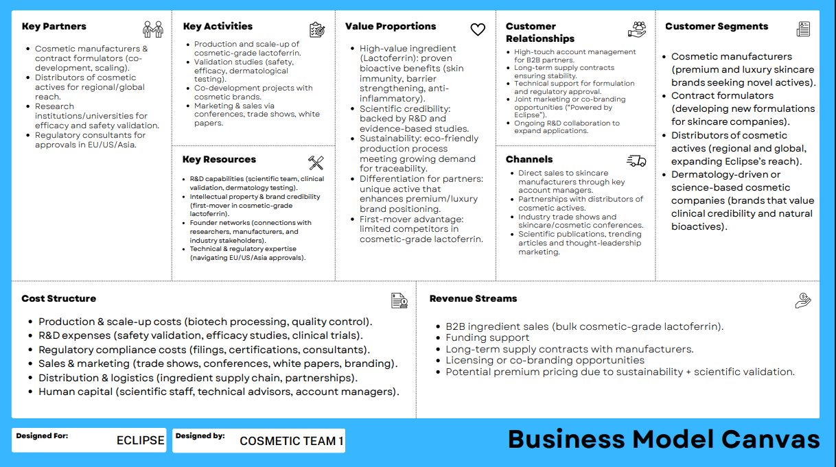
Means Inventory for Eclipse
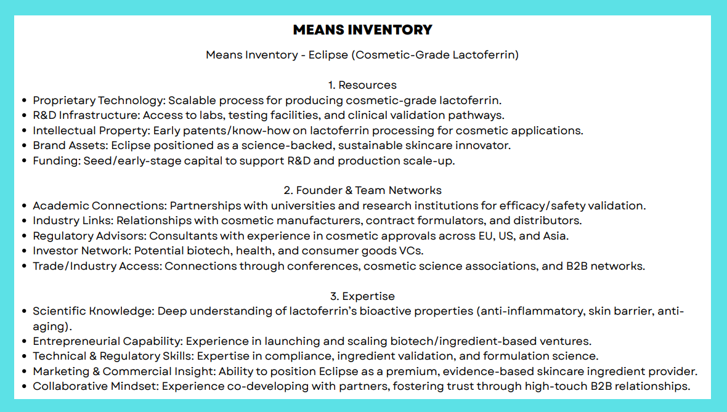

Diary Entry #3 | 3rd September
Our team received our A1 presentation marks, and scored 17/20, which was a strong result and kept the group motivated. The feedback from Jack was valuable, in particular to shift our focus from prioritising internal analysis to external validation. This made us focus on more customer driven results, rather than research heavy analysis. We had initially planned to start interviews around Week 5, but this advice prompted us to prioritise early customer discovery and real-world validation before refining the BMC any further.
This aligned well with our ongoing feedback (email correspondence) from Siobhan, who reviewed our first draft of interview questions. She encouraged us to keep questions open ended to avoid leading participants into answers and to focus on past behaviour as a stronger predictor of future actions. For example, asking when participants last tried a new product, what drew them to it, and how they decided to purchase it. Siobhan’s guidance also led us to reframe our outreach strategy and conduct interviews as university researchers, rather than approaching brands on behalf of Eclipse.
From this process, I learned it is vital to have the mindset of ‘validation must drive design’, not follow it, and that we must test and validate assumptions early before committing to a fixed direction to ensure our decisions are driven by real customer insights rather than internal speculation. Moving forward, our focus will be conducting interviews with a variety of potential stakeholders, such as women (16+), men, and beauty retail workers, to refine our understanding of customer pain points, to utilise these insights and guide Eclipse’s next steps in identifying the strongest market fit for lactoferrin in skincare.
Table of Interview Roles
Interviewer | Women (16+) | Men | Beauty Retail | Total
Bella | 3 | 3 | 1 | 7
Ruby | 3 | 3 | 1 | 7
Paige | 5 | 1 | 0 | 6
Crystal-Rose | 3 | 3 | 1 | 7
Eloise | - | 3 | - | 3
Total | 14 | 13 | 3 | 30

Diary Entry #4 | 15th September
Our team completed our customer and professional interviews, speaking to a total of 30 participants across all age ranges: 14 women, 13 men, and 3 beauty retail professionals. Prior to conducting interviews, we assumed women would prioritise anti-aging benefits, men would be largely uninterested in skincare beyond convenience, and beauty retail professionals would be intrigued by the idea of the ingredient lactoferrin. This was however challenged and we found some interesting results in regards that woman valued gentleness and hydration over anti-aging, and rely heavily on reviews and social proof before purchasing. Men, while still preferring convenience, were more open to evidence based and natural ingredients more than we had assumed, particularly if recommended by partners or friends. Retail Professionals were enthusiastic of lactoferrin, provided there was evidence of benefits.
Mapping these insights using empathy mapping allowed us to inspect each segments thoughts and feelings, clarifying their underlying needs that made not have been clear originally. From this process, I learned that assumptions can mislead us if not tested. It is clear that the real-world data we had collected has challenged and brought to light out internal biases. As mentioned prior, this reinforced the importance of early validation and iterative design, ensuring our approach to Eclipse’s market entry aligns with the actual behaviours and needs of both consumers and industry partners.
Table of Empathy Mapping
Segment | Says | Thinks | Does
Women (16+) | “I want products that are gentle but effective.” “I check ingredients before buying.” “Glow and avoiding breakouts are my biggest focus.” “If it was reasonably priced and had great reviews, yes.” “Gentleness first.” | Wants products that suit lifestyle (fast, convenient). Natural/science-backed ingredients build trust. Prefers gentle yet effective products. Seeks social proof before purchase. Prioritises hydration, simplicity, and visible results. | Researches online. Buys mid-range products ($40–70). Uses daily skincare routines. Reads TikTok reviews. Shops at Mecca, Priceline, Chemist Warehouse. Avoids harsh actives.
Men | “I just use soap.” “Convenience and effectiveness matter.” “Price is important.” “I’d try it if someone gave it to me.” “I’d buy it if sports guys advertised it.” | Skincare is optional and feminine-coded. Only necessary if visible issue arises. Convenience > branding. Trusts partner’s choices. Open to natural, simple, science-backed ingredients if proven. | Rarely researches products. Uses basic cleanser/moisturiser (if any). Relies on partner for purchases. Uses sunscreen occasionally. Prefers quick, minimal routines.
Beauty Retail Professionals | “Clients want results.” “Education and demonstration are crucial.” “Lactoferrin would be appealing.” “Retinol is most asked about.” “People prefer leave-on products.” | Simplify messaging for new ingredients. Customised skincare is the future. Evidence and client feedback are key. Natural + scientific ingredients are powerful if proven. | Analyses clients’ skin. Tests and recommends products. Follows trends. Educates clients on routines. Tracks progress.
Segment | Feels | Pains | Gains
Women (16+) | Excited about innovative products. Frustrated by irritation or hype. Relaxed during skincare. Confident when skin feels hydrated. Finds routine therapeutic. | Overwhelmed by too many options. Sensitive skin, irritation. Wasted money on overhyped products. Distrust of marketing. Dryness and confusion from conflicting advice. | Convenience and simplicity. Visible hydration and glow. Trust in science-backed, ethical ingredients. Confidence and comfort in routine. Enjoyment from self-care.
Men | Neutral or indifferent toward skincare. Confident without routine. Feels mild guilt about neglect. Appreciates simplicity. Feels good when skin looks healthy. | Skincare seen as unnecessary or feminine. Dislikes complex routines. Price sensitivity (<$30). Low awareness of skin health. Relies on partner’s guidance. | Simple, fast routines (<5 mins). Feels fresh and clean. Compliments motivate engagement. Open to products that are natural, affordable, and effective. Willing to pay more if visible benefits.
Beauty Retail Professionals | Confident in expertise. Curious but cautious with innovation. Frustrated by misinformation. Proud when clients see results. | Price-sensitive customers. Male apathy toward skincare. Misinformation and unrealistic expectations. Limited small-business resources. | Loyal, informed customers. Ability to differentiate via new, science-backed ingredients. Visible client improvements. Trust and credibility in professional recommendations.

Diary Entry #5 | 9th – 15th October
At this stage, our team focused on consumer validation through surveys and concept testing. Before distributing the surveys, we sought feedback from Jack. Initially, our questions included both product and brand-level assumptions, but Jack advised that we focus on product-level concepts first, testing 2–3 potential value propositions visually rather than diving into branding prematurely. He emphasized that choices and rankings generate the most actionable data and that surveys can simultaneously test multiple MVP variations. This guidance shifted my perspective, I realized our initial approach risked overcomplicating data collection and might not reveal which concepts resonated most with consumers.
Following this feedback, we collaboratively refined our survey questions, Eloise designed the survey, and from then on, I developed the flyers to promote participation for the survey. Eloise and Bella created mock product concepts to test potential value propositions visually. Over the next few days, we distributed flyers in a variety of locations such as shopping centres, university bathroom stalls, public parks, bus stops, and online skincare groups. So far, we’ve gathered responses from 53 participants, providing us with a large variety of consumer insights.
From this process, I learned the value of iterative testing and multiple touchpoints, in that real-world exposure reveals how consumers respond to concepts differently than expected. Looking ahead, our next steps involve B2B outreach to APAC cosmetic brands via LinkedIn, targeting product development managers to understand sourcing and validation processes. We will also test the three value propositions with guidance and feedback from local aestheticians. These activities will extend our validation from consumers to industry partners, ensuring our insights guide actionable, market-aligned strategies for Eclipse.
Survey Link
https://uniofqueensland.syd1.qualtrics.com/jfe/form/SV_aWQgDJUVLrtNQeG
Flyer Designs
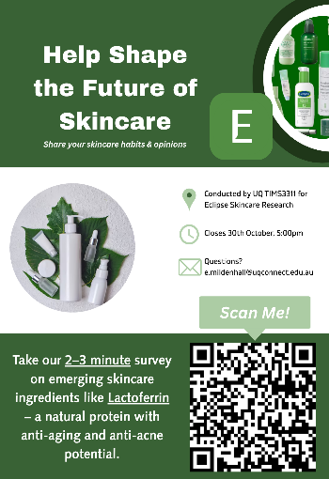

Mock-Up Product Designs
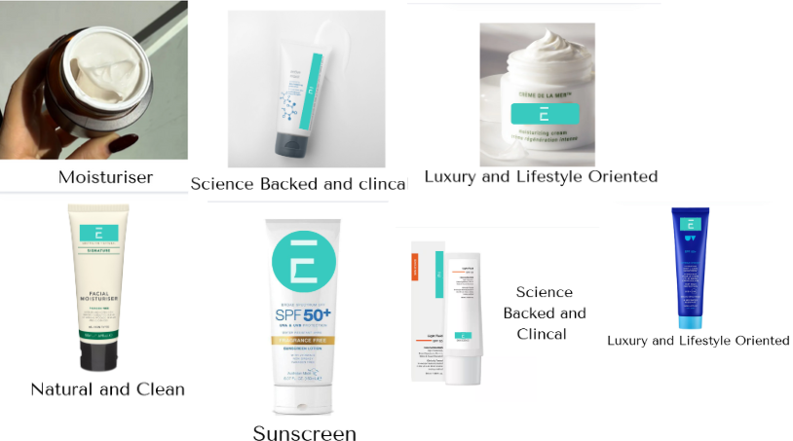
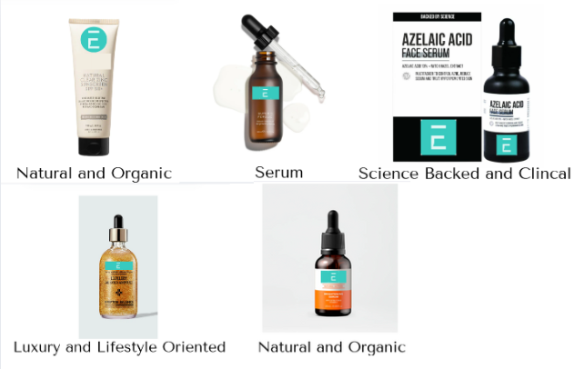

Public Flyer Handouts
